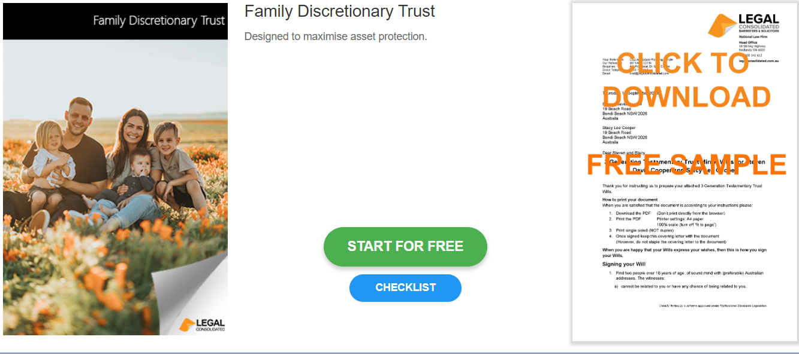

Family Discretionary Trust

Start building your document for free:
- Select START FOR FREE - the building process is free: https://legalconsolidated.com.au/family-discretionary-trust-intro/
- Answer the questions. Read the hints and watch the training videos. Educate and be empowered.
- Telephone the law firm for help answering the questions.
- Select Lock and Build and enter your credit card details.
- Within seconds, you get our cover letter and the finished document.
Trust Name

• Name of your Family Trust
Trustees

•Trustee Name
(ACN if a company)

• Trustee Address
Appointors

•Appointors Name
(ACN if a company)

• Appointors Address

Back-up Appointors

•Who are the back-up Appointors

Settlor

•Settlor Name

•Settlor Address

•Settled Sum

Default Beneficiaries

•Who are the Default Beneficiaries

