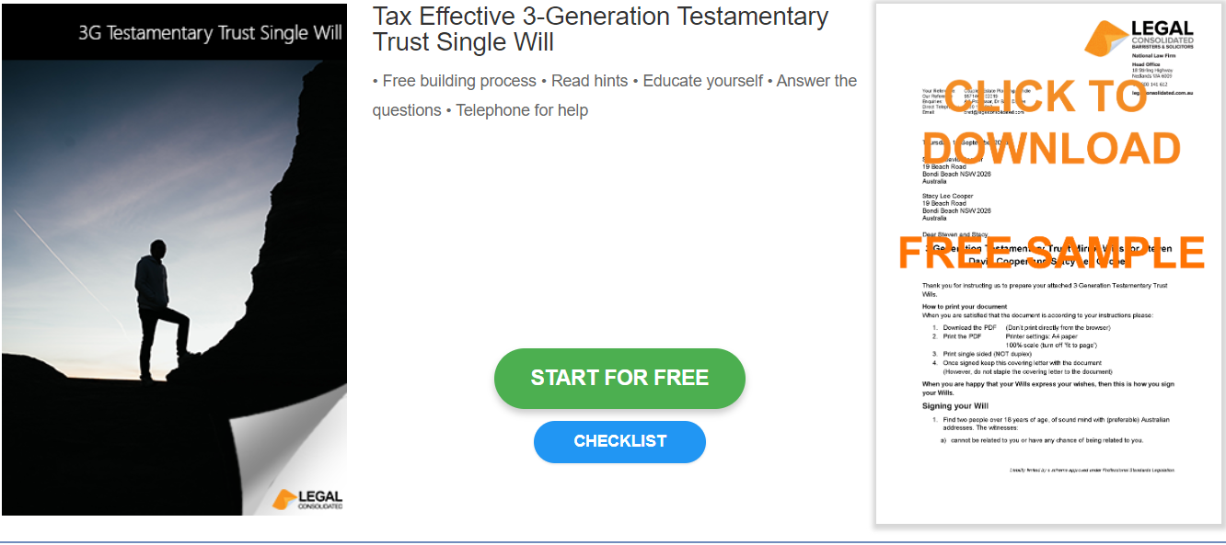

Single Will – Tax Effective 3G Testamentary Trust

Start building your document for free:
- Select START FOR FREE - the building process is free: https://legalconsolidated.com.au/single-will-tax-effective-with-choice-of-beneficiaries-intro/
- Answer the questions. Read the hints and watch the training videos. Educate and be empowered.
- Telephone the law firm for help answering the questions.
- Select Lock and Build and enter your credit card details.
- Within seconds, you get our cover letter and the finished document.
Your Details

• Your Full Name

• Your Date of Birth

• Your Address

Alias Names

• Full Alias Name
(if applicable)

Executors

•Executors Name

• Executors Address

Age of Majority

•Age of Majority

Specific Gifts

•Name of gift
(if applicable)

•Person receiving
gift (if applicable)
Beneficiaries

• Beneficiaries Name

• Beneficiaries Address

• Beneficiaries Percent Interest
Disaster Clause

• Beneficiaries Name
(if applicable)

• Beneficiaries Address
(if applicable)

• Beneficiaries Percent
Interest (if applicable)
Guardians

• Guardians Name
(if applicable)

• Guardians Address
(if applicable)
Challengers

• Challengers Name
(if applicable)

• Challengers Address
(if applicable)
Contemplation of Marriage/Divorce

• Persons Name
(if applicable)

• Persons Address
(if applicable)

